**SAVEETHA SCHOOL OF ENGINEERING**

**CSA1142-OBJECT ORIENTED ANALYSIS AND DESIGN**

**QUESTION 20: LIBRARY MANAGMENT SYSTEM**

**USE CASE**

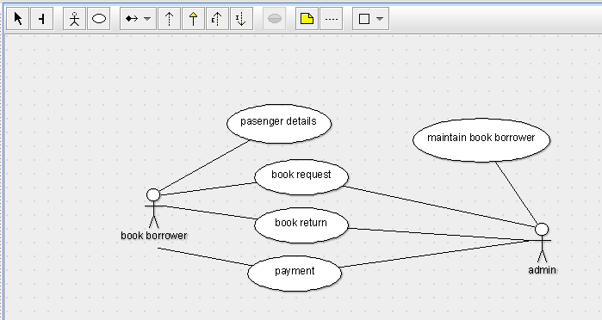

STATE DIAAGRAM

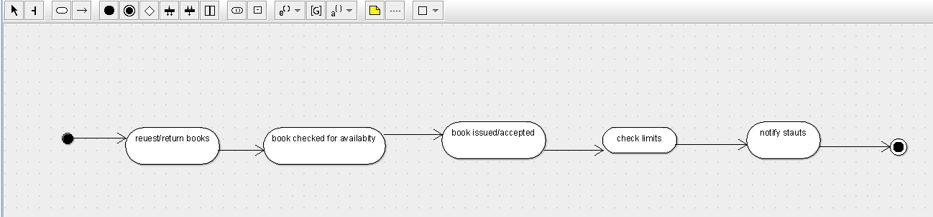

SEQUENCE DIAGRAM

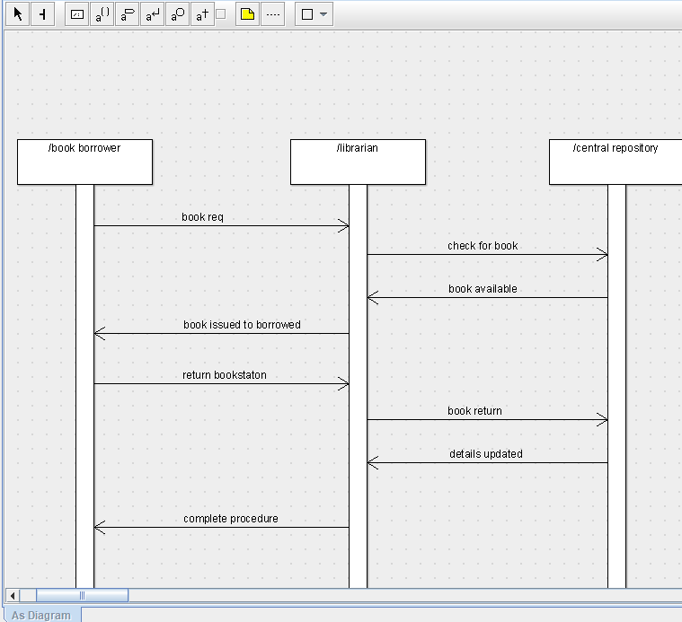

DEPLOYMENT DIAGRAM

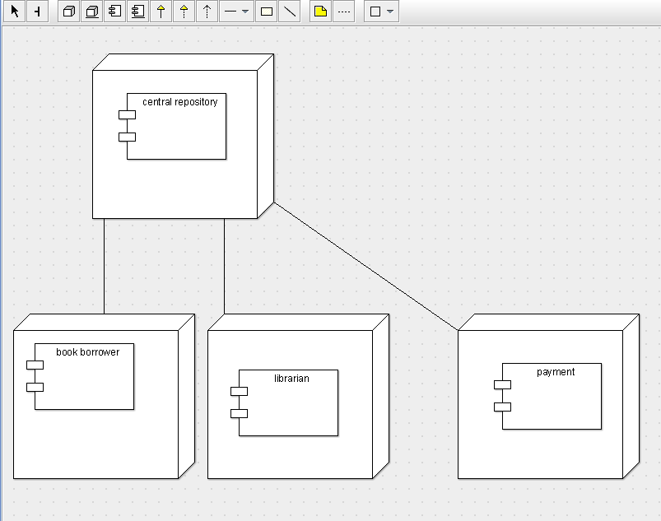

COMPONENT DIAGRAM

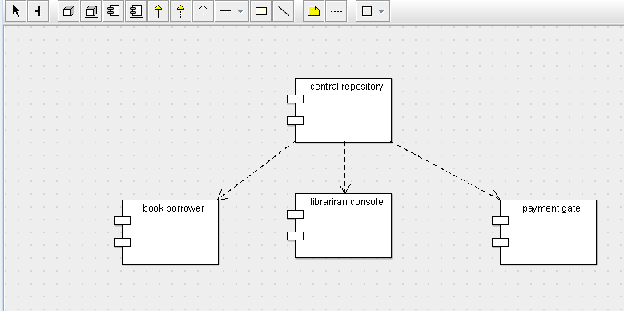

COLLABORATION DIAGRAM

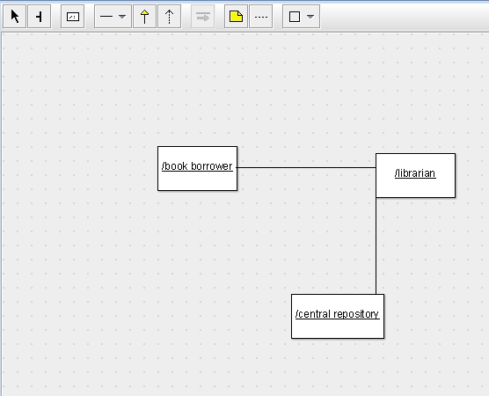

CLASS DIAGRAM

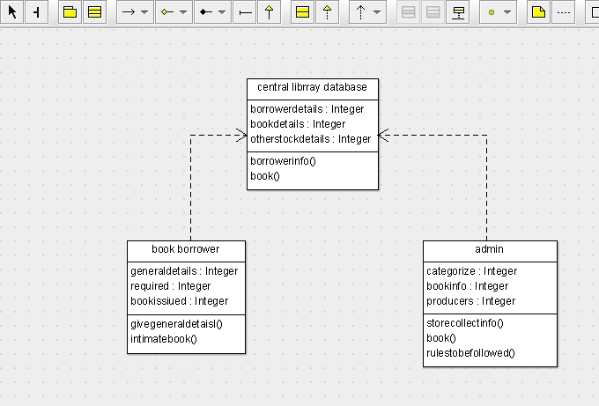

ACTIVITY DIAGRAM

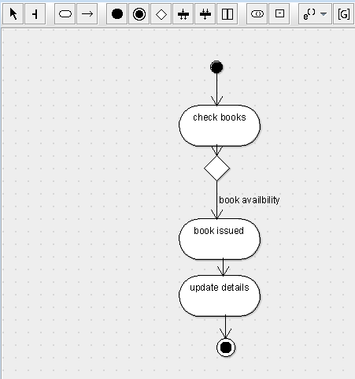

SKELETON CODE;

import java.util.Vector;

public class admin {

private Integer login;

public Integer password;

private Integer date;

public Integer fineamt;

public Vector mybook bank;

public void checklogininfo() {

}

public void checkdate() {

}

public void checkamt() {

}

}

import java.util.Vector;

public class book bank {

public Integer user;

public Integer login;

public Vector mystudent;

public Vector myadmin;

public void getdetails() {

}

public void verify() {

}

}

import java.util.Vector;

public class student {

private Integer id;

public Integer password;

public Vector mybook bank;

public void checkid() {

}

public void checkpass() {

}

}